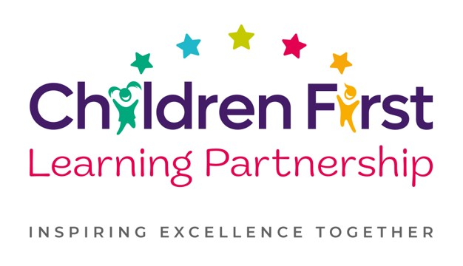

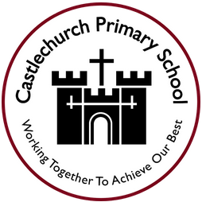

Music Policy 2026

February 2027
To be reviewed:
________________
Agreed and ratified by the Local Advisory Board on:
Headteacher – Mr L.Anderson-Pugh

Responsible Officer:
Mrs. T Drinkwater
Chair of Local Advisory Board:
The CFLP Art Policy in respect of the Children First Learning Partnership has been discussed and adopted by the Local Advisory Board.

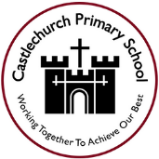

Castlechurch Primary School
Music Policy 2026

The overall intent of our school curriculum is to:
Recognise uniqueness: in our pupils, staff, resources and whole school community.
Be Inclusive: recognising learning styles, learning needs at all levels and providing solutions to any barriers to learning we encounter.
Engage and Inspire: through knowledge rich, highly enriched, progressive and purposeful contexts.
Promote Aspiration: offering challenge, accountability and responsibility for their learning.
Create citizens of the Future: who thrive on responsibility, see difference as a strength of our community and use democracy to embed their own values and beliefs.
Our Music curriculum strives to drive all of these intentions and links very closely to the achievement and development of them all.
Intent
To engage and inspire pupils to develop a love of music and their talent as musicians, and so increase self-confidence, creativity and a sense of achievement. We aim to achieve this through allowing the children:
- To create and perform your own music.
- To learn a musical instrument and have the opportunity to progress further
- An awareness and appreciation of different musical traditions and genres.
- To take part in a diverse range of musical activities.
- An excellent understanding of the historical, social and cultural origins of music.
- To listen to, discuss and evaluate how music is created.
- The ability to give verbal and written explanations, using musical language.
Implementation
We use the Development Matters and National Curriculum documents to inform the delivery of Music at Castlechurch Primary School. We combine these with the scheme of work; Get Set 4 Music.

Our progression documents show a build-up of knowledge and skills across the following areas:
KS1 and KS2 – listening and appraising a variety of music from different genres, time periods and instrumentation - knowledge of the inter related elements of music - using voices in an ensemble and as a soloist - developing the skills of playing an instrument as both a soloist and as part of an ensemble - using improvision as a compositional and performance tool – developing our recording of musical ideas through composing.

The Elements of Music
In order to ensure the depth and breadth of our Music curriculum, it has been designed in a way in to covers all aspects of the Nation Curriculum. Understanding the Elements of Music both from a listening and appraising point of view and also from a performance/compositional point of view is imperative for children to develop as musicians. They are therefore a key focus in our flow of lessons and the as part of the individual lessons themselves in order to give purpose, focus and understanding of key teaching points and objectives.

Listening and Appraising
Listening and Appraising is used in order for children to gain context, recap their previous learning and apply it to present and future learning. The main purpose and function of including it within our music curriculum in and out of the classroom is to develop children’s understanding of the elements of music, instrumentation, genres and the history of music and how it has evolved over time. Listening and Appraising work will often be used as a starter task in music lessons and will also be used when children share their learning through performance work.

Instruments
Children have opportunities to play various instruments during their time at Castlechurch. This will be progressive year on year and show a build up of skills that will allow children to develop instrumental technique that links intrinsically with the elements of music.

Singing
All children have opportunities to sing throughout the school year in both ensemble and soloist contexts. There are weekly opportunities to sing as a whole school during weekly singing assemblies where we will work on developing technique and towards whole school or class celebrational assemblies. Children also have opportunities to sing as part of class assemblies and during religious celebrations such as Christmas and Easter. Part of the lesson pathway allows singing when using call and respond to develop specific skills.

Performing
Children will be provided with plenty of opportunities to work towards and then give performances of what they have been working on. This will be soloist and ensemble contexts and can show a specific objective or the composite piece of a flow of lessons. This will give children the chance to share their development of learning various skills of how to play specific instruments and will also build self-confidence/esteem through collaborating and performing in front of others.

Improvisation and Composition
Improvisation is a key component of our musical curriculum as it teaches children to develop their understanding of the elements of music which can be applied to both performance and compositional aspects of learning. There will be opportunities to improvise in the classroom environment when thinking about composing around a specific theme/objective as well as using improvisation when collaborating in performance work where children have to think carefully about the musical choices they are making. Composition is another key component which will develop children’s understanding of not only recording ideas but also developing their understanding to read music also. This will develop from simple pictorial representations through to traditional staff notation. Throughout the year, each class will have units of work that will focus solely on composition.

Unit/Lesson Structure
A Unit of Work (Pathway)
A unit of work typically incorporates the following:
- National Curriculum Programmes of Study are used, alongside our subject specific progression documents, for long term, medium term and short term planning.
- Currently, we follow Get Set 4 Music’s schemes of work for each year group to develop understanding and skill sets across exploring (listening and appraising), teach (call and response), design (improvisation), create and apply (composition) share and evaluate (perform and critique)
- Prior Learning/Listening and Appraising - this is achieved through targeted questioning, listening activities and the analysis of a prior learning activity which demonstrates the children’s strengths and areas for development.
- Vocabulary - a wide range of Music vocabulary is to be modelled and used in context to demonstrate understanding. The vocabulary documents set out clear expectations for each year group.
- Teach/Call and Response - model specific instrumental and compositional techniques based on the elements of music, that the children are given time to refine before applying them to their own performance or composition
- Application to a composite – children’s knowledge and skills of the unit to be applied in a final performance/composition
- Evaluate – children take part in ongoing self-reflection throughout the unit culminating in a final performance of a composition or rehearsed piece to an audience.
A Lesson (Pathway)
Lessons are planned from the correct Key Stage Programmes of Study from The National Curriculum and our progression documents. Teachers will be aware of the prior learning that needs to be secure from previous year groups to ensure new content can be understood. Lessons are planned sequentially, to ensure knowledge and skills are built upon.

A lesson would typically consist of the following:
- Retrieve - used to revisit and retrieve previously taught knowledge/skills.
- Shared learning objective, success criteria and unit specific vocabulary - help to set the context for a lesson.
- Teaching exposition - a variety of strategies are used to model and explore new concepts.
- Opportunities to discuss learning - children are encouraged to speak in full sentences and reinforce vocabulary in context.
- Assessment for learning (AfL) questions - used to extend and/or support learning.
- Practise/Apply – a range of opportunities to embed skills/knowledge taught.
- Scaffolded learning activities - linked to the learning objective to ensure all children achieve the learning outcome.
- Reflection – a range of techniques are employed to encourage children to think about and discuss their own learning.
- Evaluate – refer back to learning objective and success criteria. This could be at any point throughout the lesson.
These elements could be used flexibly throughout each session.
Impact
What we aim to achieve from our Music curriculum across the Children First Learning Partnership;
To engage and inspire pupils to develop a love of music and their talent as musicians, and so increase self-confidence, creativity and a sense of achievement. We aim to achieve this through allowing the children:
- To create and perform their own music.
- To learn a musical instrument and have the opportunity to progress further
- An awareness and appreciation of different musical traditions and genres.
- To take part in a diverse range of musical activities.
- An excellent understanding of the historical, social and cultural origins of music.
- To listen to, discuss and evaluate how music is created.
- The ability to give verbal and written explanations, using musical language.

Assessment
Our impact will be measured by using both formative and summative assessment.
Formative
Throughout every lesson, teaching staff will use a range of assessment for learning techniques to drive learning and identify where support or challenge is required.
Summative
Teachers will use their ongoing assessments to inform a summative judgement regarding whether a child is working at age related expectations. Through recorded and live performances, teachers can assess how children are developing their musical skill set in both composition and rehearsed performances.

Role of Leaders
- Lead the development of Music in the school, including identifying the next steps and driving the subject forward.
- Provide CPD opportunities (training, staff meetings, planning clinics, drop-ins and ongoing support) to develop staff.
- Conduct leader research to ensure the subject knowledge and understanding of the leader is up to date. This is disseminated to staff when appropriate.
- Review, monitor and feedback current practice within the subject.
- To ensure that all resources are available for each unit.
Version | Review Date | Changes Made

